**On-page Changes Suggestions of Frobity.com**

**1 - Google Analytics Set Up:** We have checked and found Google Analytics is not set up in website. So, we have generated Google Analytics code as below. Please add this code in website before closing of head section (/head) -

<!-- Global site tag (gtag.js) - Google Analytics -->

<scriptasync src="https://www.googletagmanager.com/gtag/js?id=G-6CBQ083Q50"></script>

<script>

window.dataLayer = window.dataLayer || [];

functiongtag(){dataLayer.push(arguments);}

gtag('js', new Date());

gtag('config', 'G-6CBQ083Q50');

</script>

**2 - Google Webmaster Set Up:** We have checked and found Google Webmaster is not set up in website. So, we have generated Google Webmaster code as below. Please add this code in website before closing of head section (/head) -

<meta name="google-site-verification" content="uiKoMQJMVqG_SV08Wp09LPuCtSy9JNQMPt35a-Zi_C8" />

**3- New Web Page Creation:**

Please create new pages in website as below. Make these web pages live on website once we have received all the web content.

<https://frobity.com/freelance-tax-and-accountants-work>

<https://frobity.com/hire-freelance-web-designer>

<https://frobity.com/freelance-wordpress-web-developer>

<https://frobity.com/freelance-platform-for-web-developers>

<https://frobity.com/freelance-chartered-accountant>

<https://frobity.com/intellectual-property-law>

**4- Robots.txt Implementation:** Please upload updated Robots file on website.Check email attachment.

**5- XML Sitemap Implementation:** Please upload XML Sitemap file on website.Check email attachment.

**6- Canonicalization Check&Implementation:**We have checked and found that website is opening with multiple URLs which is a Canonical Issue and harmful for SEO.

<https://frobity.com>

<https://www.frobity.com>

<https://www.frobity.com/index.php>

<https://www.frobity.com/index.php>

We need to set Canonical Tag in website for preferred version as suggested below -

**For URL** - <https://www.frobity.com>

**Suggested Canonical Tag** - <link rel="canonical" href="https://www.frobity.com/"/>

**Note:** Need to set Canonical Tag for every page of website in same way.

**7- Internal Link Structuring & Optimization:**We have checked header and footer navigation links of website. They are working fine and linked to each other.

Few services menu in the footer of website, are not linked with their relevant pages. Please do the needful for them for linking -

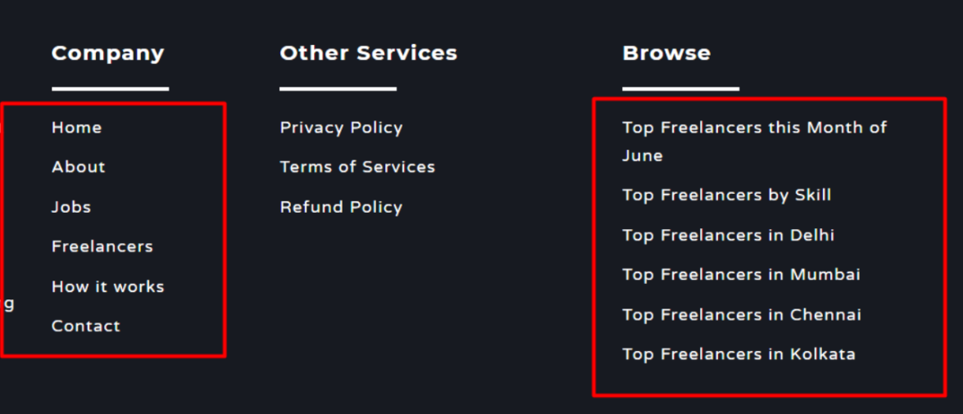

**8- Header Tags Optimization:**We have checked and found there are multiple <h1> Tag present on website. We need to keep 1 <h1> Tag in page and change other <h1> tag into <h2> tag.

**Example-**

**URL -** [**https://frobity.com**](https://frobity.com)

**Suggested <h1> Tag -** FROBITY

**Note:** Make other <h1> tag of this page into <h2> tag

**9- HTML Sitemap Creation:**HTML Sitemap is missing on website. Please create and link the sitemap in footer section of website.

**10- Image Alt Tag Optimization:**Alt Tag is missing on images. Please implement Alt Tag as suggested below -

**For URL-** [**https://frobity.com**](https://frobity.com)

**Image Path -** [**https://frobity.com/assets/img/logo.png**](https://frobity.com/assets/img/logo.png)

**Suggested Alt Tag –**Frobity

**Image Path -** [**https://frobity.com/cat/ca.jpg**](https://frobity.com/cat/ca.jpg)

**Suggested Alt Tag -** Chartered Accountant

**Image Path -** [**https://frobity.com/cat/cs.jpg**](https://frobity.com/cat/cs.jpg)

**Suggested Alt Tag -** Company Secretary

**Image Path -** [**https://frobity.com/cat/accountant.jpg**](https://frobity.com/cat/accountant.jpg)

**Suggested Alt Tag -** Accountant

**Image Path -** [**https://frobity.com/cat/form-return-filling.jpg**](https://frobity.com/cat/form-return-filling.jpg)

**Suggested Alt Tag -** Forms/Return Filling

**Image Path -** [**https://frobity.com/cat/registrationm.jpg**](https://frobity.com/cat/registrationm.jpg)

**Suggested Alt Tag -** Registration Services

**Image Path -** [**https://frobity.com/cat/website.png**](https://frobity.com/cat/website.png)

**Suggested Alt Tag -** Web

**Image Path -** [**https://frobity.com/cat/networking.jpg**](https://frobity.com/cat/networking.jpg)

**Suggested Alt Tag -** Networking

**Image Path -** [**https://frobity.com/cat/dataanalysis1.png**](https://frobity.com/cat/dataanalysis1.png)

**Suggested Alt Tag -** Data Science & Analytics

**Image Path -** [**https://frobity.com/cat/architecture.jpg**](https://frobity.com/cat/architecture.jpg)

**Suggested Alt Tag -** Architecture

**Image Path -** [**https://frobity.com/cat/desgin-creative.png**](https://frobity.com/cat/desgin-creative.png)

**Suggested Alt Tag -** Design &Creative

**Image Path -** [**https://frobity.com/cat/writing.jpg**](https://frobity.com/cat/writing.jpg)

**Suggested Alt Tag -** Writing

**Image Path -** [**https://frobity.com/cat/translation.jpg**](https://frobity.com/cat/translation.jpg)

**Suggested Alt Tag -** Translation

**Image Path -** [**https://frobity.com/cat/legal.jpg**](https://frobity.com/cat/legal.jpg)

**Suggested Alt Tag -** Legal

**Image Path -** [**https://frobity.com/cat/admin-support.jpg**](https://frobity.com/cat/admin-support.jpg)

**Suggested Alt Tag -** Admin Support

**Image Path -** [**https://frobity.com/cat/customer-service.png**](https://frobity.com/cat/customer-service.png)

**Suggested Alt Tag -** Customer Service

**Image Path -** [**https://frobity.com/cat/Sales-Marketing.jpg**](https://frobity.com/cat/Sales-Marketing.jpg)

**Suggested Alt Tag -** Sales & Marketing

**11- Meta Tags Optimization:**Please update Meta Tags on website as below –

**For URL** -[**https://frobity.com**](https://frobity.com)

**Existing Meta Title-**frobity | Freelancing Platform

**Existing Meta Description-**Not Available

**Target Keywords-**

* hire freelancers india

**New Meta Title-**Find &Hire Freelancers in India| Freelancing Platform | Frobity

**New Meta Description-** Hire the best freelancers for your work in India.A concrete framework for high paying jobs and individual skills enhancements. Get online projects & earn money.